Yeswanth Sai Edhala
Manoj Kumar Reddy Bajjuri
Group Assignment 1

Section 1: Goal, Question, and Metrics (GQM Approach)

Goal
The primary goal of this study is to evaluate the internal quality of open-source Java systems by analyzing their object-oriented design metrics. The study aims to identify patterns and relationships between various software metrics that may influence software maintainability, complexity, and coupling levels.
Questions
1. What are the average values and variations of key object-oriented metrics (LOC, WMC, CBO) across the selected Java projects?
2. How do software size metrics (e.g., Lines of Code) relate to complexity and coupling metrics (e.g., WMC, CBO)?
3. Can we have observable differences in metric patterns in projects with different domains?

Metrics
Metric | Description | Purpose
LOC (Lines of Code) | Total number of lines of code in a class | Measures software size
WMC (Weighted Methods per Class) | Number of methods and their complexity | Indicates class complexity
CBO (Coupling Between Objects) | Number of classes to which a class is coupled | Measures inter-class dependency

Section 2: Subject Programs (Dataset Description)
Five open-source Java projects were selected as the subjects of this empirical study. The projects vary in size, domain, and functionality, providing a diverse dataset for metric-based analysis. The CK tool was used to extract design-level metrics from these systems.
Project Name | Repository Link | Domain / Purpose | Language | LOC | Main Functionality | Contributors
Apache Dubbo | https://github.com/apache/dubbo | Distributed systems, RPC framework | Java | ~600K | Provides a high-performance, Java-based RPC framework for building microservices. | 612
Apache ShardingSphere | https://github.com/apache/shardingsphere | Database middleware | Java | ~900K | Offers data sharding, distributed transactions, and database governance tools. | 628
Bazel | https://github.com/bazelbuild/bazel | Build system | Java | ~1.2M | Open-source build and test tool supporting large-scale, multi-language projects. | 1066
Apache RocketMQ | https://github.com/apache/rocketmq | Messaging and streaming platform | Java | ~500K | Provides a distributed messaging and streaming platform for event-driven systems. | 557
Facebook Fresco | https://github.com/facebook/fresco | Image loading library | Java | ~400K | Efficient image loading and display library for Android applications. | 230
We cloned each of these JAVA projects from its public GitHub repository. The selected systems represent different categories (frameworks, middleware, libraries, and tools) to ensure variety in design and structure. The source code for each project was analyzed using the CK-metrics tool to extract class-level metrics like WMC, LOC and CBO. These metrics form the dataset used for our analysis in the next sections.

Section 3: Tool Description
We used the CK-metrics Tool (Chidamber and Kemerer Metrics Calculator) for extracting metrics. It is an open-source Java program developed by Maurício Aniche that calculates several well-known object-oriented design metrics like coupling(CBO), FANIN, FANOUT, WMC, DIT, RFC, LCOM, LOC, LoopQty and many more from Java source code that will help the developer to observe the maintainability of the program.
Tool Overview:
- Tool Name: CK-Metrics Calculator
- Version Used: 0.7.1-SNAPSHOT
- Repository: https://github.com/mauricioaniche/ck
- Language: Java
- Execution Command:
java -jar target/ck-0.7.1-SNAPSHOT-jar-with-dependencies.jar <project_path> true 0
Output: CSV files containing class-, method-, and package-level metrics.
The metrics are calculated automatically for each Java class of the project as mentioned in the above command and stored in a CSV file in a read only type for further statistical analysis.
Reference:
Aniche, M. (2016). CK: Java Code Metrics Tool. Retrieved from https://github.com/mauricioaniche/ck
Section 4: Graphs, report and results
This section presents the results of the empirical study on the effect of class size on software maintainability.
Two relationships were analyzed for each of the five selected open-source Java projects:
LOC vs WMC (class size vs complexity)
LOC vs CBO (class size vs coupling)
Scatter plots were generated for each pair of metrics, and correlation values were calculated to measure the strength of the relationships.

Apache Dubbo
The correlation between LOC and WMC (0.814) indicates a strong positive relationship, meaning that larger classes in Dubbo tend to have higher complexity.
Similarly, the LOC vs CBO correlation (0.538) suggests that bigger classes are also more coupled to other classes.
These results imply that maintainability decreases as class size increases, since more lines of code lead to more complex and interconnected logic.
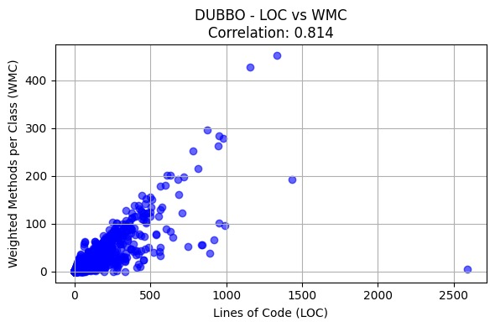
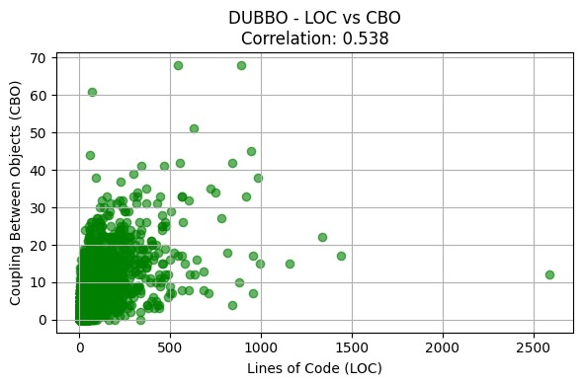

Apache ShardingSphere
For ShardingSphere, the correlations (0.957 for LOC–WMC and 0.776 for LOC–CBO) also show a strong positive relationship.
This suggests that as the class size grows, both the internal complexity and coupling rise noticeably.
Therefore, large classes in this project are likely harder to maintain and modify safely.
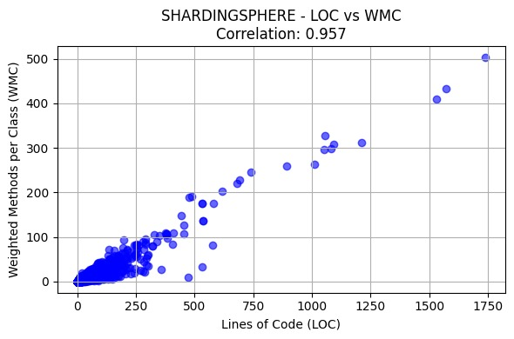
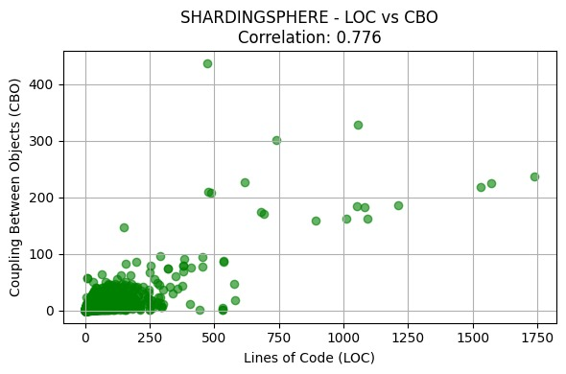

Bazel
Bazel has the lowest correlations (0.860 for LOC–WMC and 0.961 for LOC–CBO).
The results indicate that class size has a moderate effect on complexity and coupling, meaning that maintainability issues exist but are less pronounced.
Bazel’s structure may be more modular, which could explain the weaker correlation.
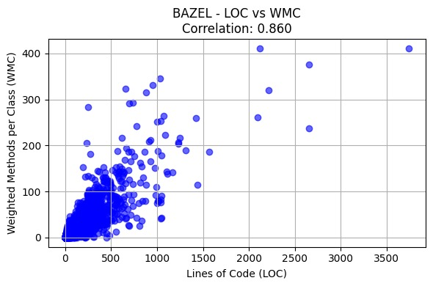
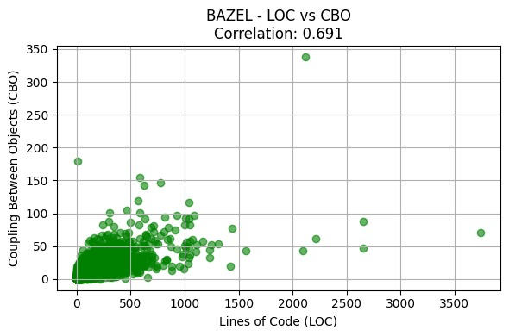

Apache RocketMQ
RocketMQ shows the strongest LOC–WMC correlation (0.935), indicating that class complexity grows rapidly with size.
The LOC–CBO correlation (0.740) also shows that bigger classes are more dependent on other classes.
This combination of high complexity and coupling highlights that large classes in RocketMQ are less maintainable.
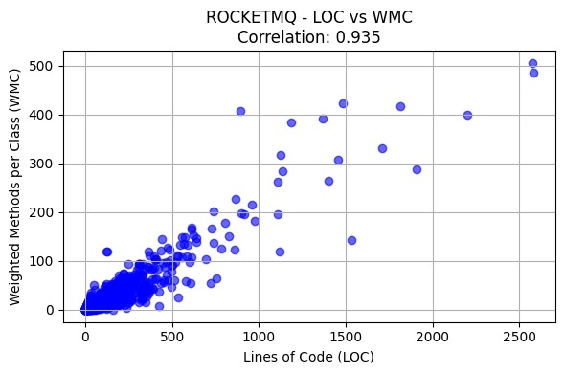
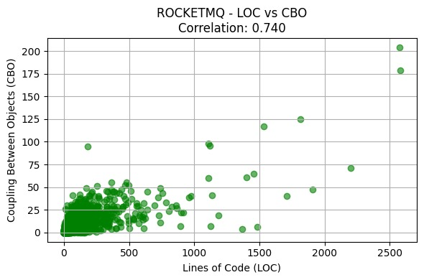
Facebook Fresco
Fresco demonstrates moderate correlations (0.839 for LOC–WMC and 0.745 for LOC–CBO).
This means that while larger classes are generally more complex, the relationship with coupling is weaker compared to other projects.
Maintainability is still affected, but less severely than in Dubbo or Rocketmq.
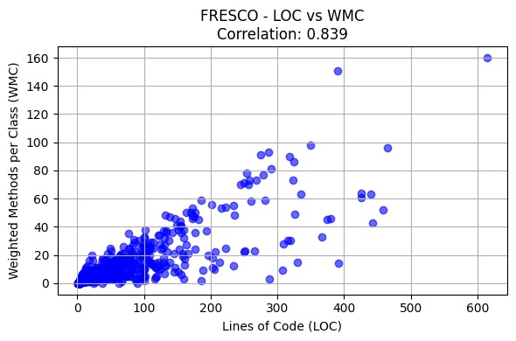
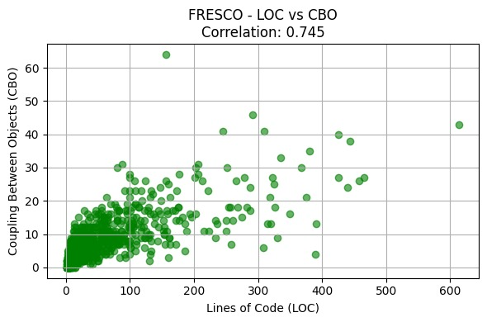
Correlation table:

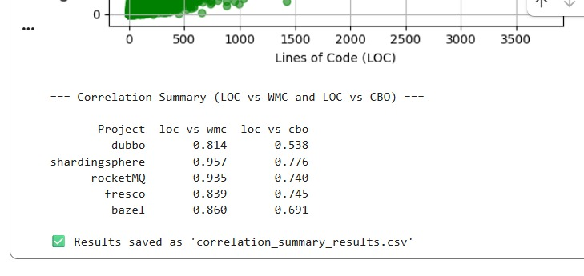

Across all five projects, there is a consistent positive relationship between class size (LOC) and both complexity (WMC) and coupling (CBO).
This means that as classes grow larger, they tend to become more complex and interconnected, reducing maintainability.
Projects like RocketMQ and Dubbo showed the strongest relationships, while Bazel had the weakest, likely due to differences in project architecture and coding practices.
Section 5: Conclusion
The study found that as class size increases, both complexity (WMC) and coupling (CBO) also rise.
This means larger classes are generally harder to understand, modify, and maintain.
Projects like RocketMQ and Dubbo showed stronger correlations, while Bazel had weaker ones, possibly due to better modular design.
Overall, the results confirm that keeping classes smaller and less connected improves software maintainability.

References:
https://github.com/apache/dubbo
https://github.com/apache/shardingsphere
https://github.com/bazelbuild/bazel
https://github.com/apache/rocketmq
https://github.com/facebook/fresco
https://ieeexplore.ieee.org/document/295895

